BAT WEBS SOLUTION

# TASK 2: Exploring Machine Learning Concepts

## ARTIFICIAL INTELLIGENCE/MACHINE LEARNING/DEEP LEARNING()

{picture depicting the subsets}

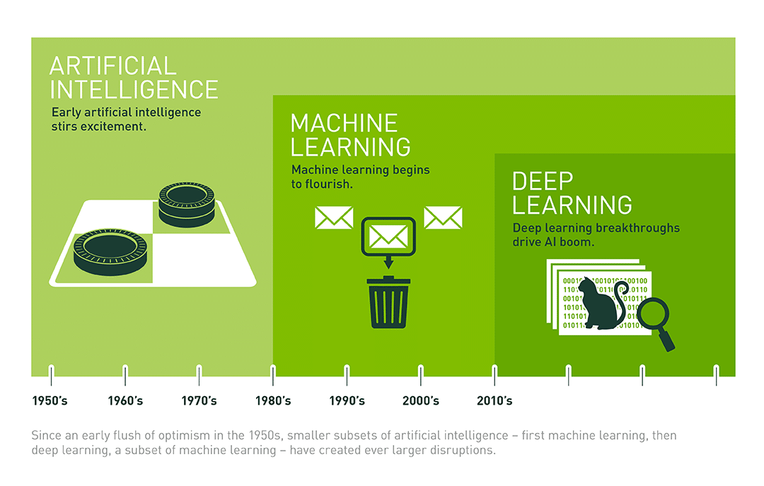

* **Artificial Learning:** It refers to the development of computer systems and algorithms that simulate human intelligence. The goal of AI is to enable machines to perform tasks such as problem-solving, learning, reasoning, and decision-making—capabilities traditionally associated with human intelligence.

**EXAMPLES-**

* Virtual Personal Assistants (e.g., Siri, Google Assistant)
* Recommendation Systems (e.g., Netflix recommendations)
* Natural Language Processing (NLP) for language understanding
* Game Playing (e.g., chess-playing programs)
* **Machine Learning:** Machine Learning is a subset of Artificial Intelligence that involves the development of algorithms and statistical models that enable computers to improve their performance on a specific task over time without being explicitly programmed. ML systems learn from data, identifying patterns and making predictions or decisions based on the information they have been exposed to.

**EXAMPLES-**

* Linear Regression for predicting numerical values
* Support Vector Machines for classification tasks
* Decision Trees for decision-making processes
* K-Nearest Neighbors for pattern recognition
* **Deep Learning:** Deep Learning is a specialized branch of Machine Learning that focuses on artificial neural networks with deep architectures, typically involving multiple layers (deep neural networks). DL algorithms attempt to automatically learn hierarchical representations of data, making them particularly effective in handling complex and unstructured information. This approach has shown remarkable success in tasks such as image and speech recognition, natural language processing, and other pattern recognition applications.

**EXAMPLES-**

* Convolutional Neural Networks (CNNs) for image recognition
* Recurrent Neural Networks (RNNs) for sequential data analysis
* Generative Adversarial Networks (GANs) for generating new data
* Transformer models for natural language processing

## SUPERVISED & UNSUPERVISED LEARNING

*“So basically when working with ML we divide the working machine in two ways-”*

* **SUPERVISED LEARNING:** Supervised learning is a type of machine learning where the algorithm is trained on a labelled dataset, which means that the input data used for training is paired with corresponding output labels. The goal of supervised learning is to learn a mapping or function from the input data to the output labels, allowing the algorithm to make predictions or decisions on new, unseen data. During training, the algorithm adjusts its parameters based on the known input-output pairs, minimizing the difference between predicted and actual outputs. Common tasks in supervised learning include classification and regression.
* **UNSUPERVISED LEARNING:** Unsupervised learning is a type of machine learning where the algorithm is given input data without explicit output labels. The goal is to uncover hidden patterns, relationships, or structures within the data. Unlike supervised learning, there is no predefined correct output, and the algorithm explores the data to find inherent structures or groupings. Common tasks in unsupervised learning include clustering, dimensionality reduction, and association rule learning.

I CAN CONCLUDE THAT I WAS ABLE TO GET INTO THIS FIELD BY HAVING INTEREST AND THE WONDER IT CAN DO LIKE OPTIMIZING AND MAKING EVERYTHING SO SMART.